前20个表型

Outcome 1807_irnt;Father's age at death

Variable

20107_10;Illnesses of father: Alzheimer's disease/dementia

20107_13;Illnesses of father: Prostate cancer;binary;

6145_3;Illness injury bereavement " stress in last 2 years: Death of a close relative

20107_2;Illnesses of father: Stroke

3526_irnt;Mother's age at death

4501;Non-accidental death in close genetic family

6138_100;Qualifications: None of the above，binary "Which of the following qualifications do you have?

6138_1;Qualifications: College or University degree

20107_3;Illnesses of father: Lung cancer

6150_100;Vascular/heart problems diagnosed by doctor: None of the above

20107_1;Illnesses of father: Heart disease

20107_11;Illnesses of father: Parkinson's disease

20111_100;Illnesses of siblings: None of the above (group 1) Group 1 : Heart disease Stroke High blood pressure Chronic bronchitis/emphysema Alzheimer's disease/dementia Diabetes. Group 2 : Parkinson's disease Severe Depression Lung cancer Bowel cancer Prostate cancer Breast cancer.

2139_irnt;Age first had sexual intercourse

20111_1;Illnesses of siblings: Heart disease

23099_irnt;Body fat percentage

20107_9;Illnesses of father: Diabetes

23111_irnt;Leg fat percentage (right)

1787;Maternal smoking around birth

20107_8;Illnesses of father: High blood pressure

另外，我做了上述八大疾病的linear regression（不知道有没有用）

Y = 0.12x1 + 0.10x2 + 0.07x3 - 0.06x4 -0.06x5 + 0.05x6 + 0.05x7 + 0.04x8

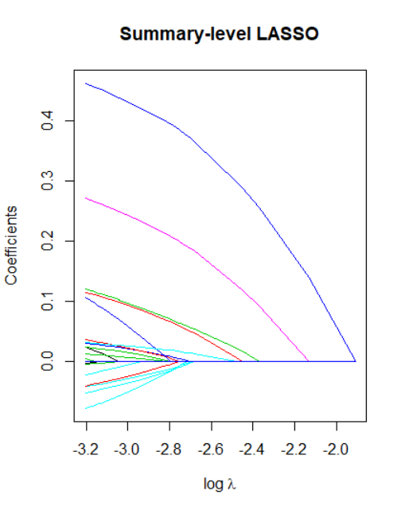

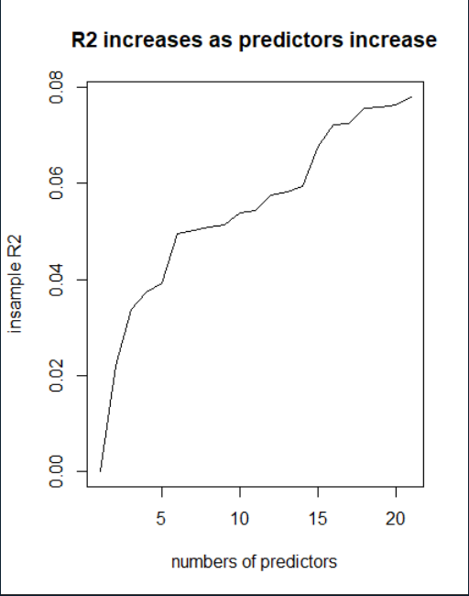

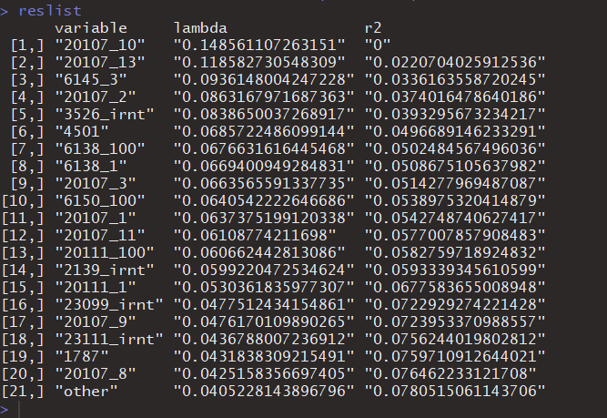

**前20的表型全部删掉**

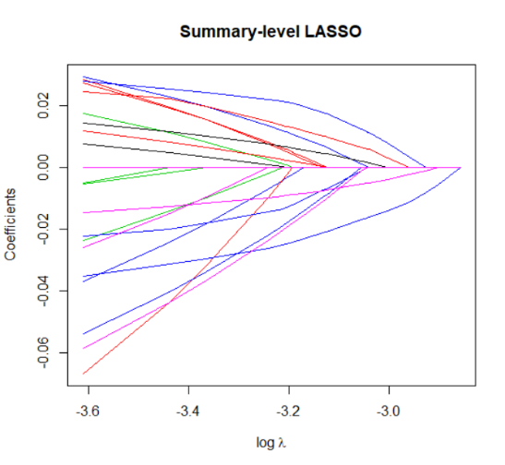

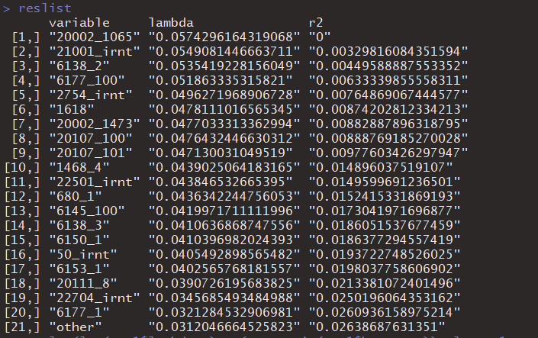

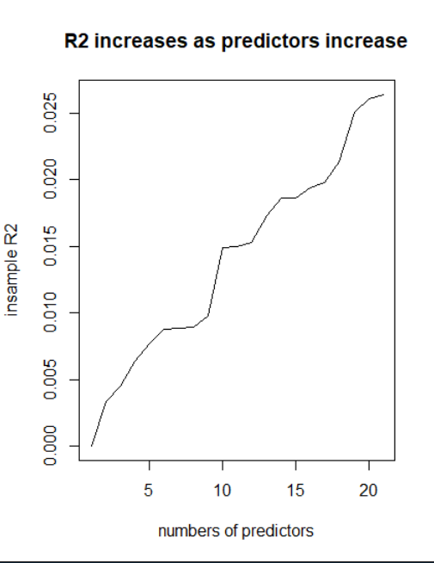

**Comparison between two R2**

